Q1a)

[x21,n21]= stepseq(0,0,21);

[x22,n22]= stepseq(21,0,21);

[x23,n23]=sigadd(x21,n21,-x22,n22);

n1=n23;

x1= n1.\*(0.9.^n1).^x23;

w1= linspace(-pi,pi,201);

X1= dtft(x1,n1,w1);

magX1=abs(X1);

phaX1=angle(X1);

figure;

subplot(2,1,1);

plot(w1/pi,magX1);

xlabel('\omega/\pi');

ylabel('|X|');

title('Magnitude response');

subplot(2,1,2);

plot(w1/pi,phaX1);

axis([-1,1,-3.5,3.5]);

phatick=[-pi:1.047:pi];

xlabel('\omega/\pi');

ylabel('Radians');

title('Phase response');

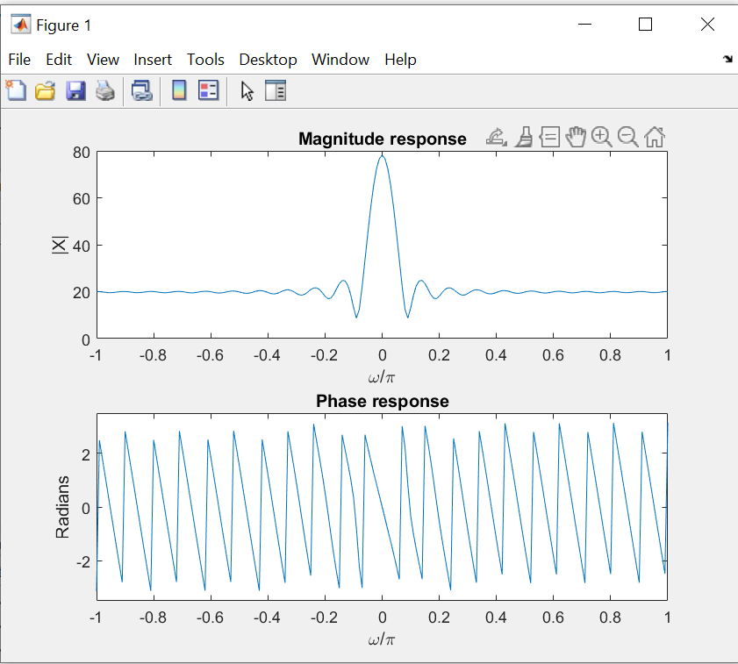

Q1 b)

x2=[4 3 2 1 1 2 3 4];

n2=[0:7];

w2= linspace(-pi,pi,201);

X2=dtft(x2,n2,w2);

magX2=abs(X2);

phaX2=angle(X2);

figure;

subplot(2,1,1);

plot(w2/pi,magX2);

xlabel('\omega/\pi');

ylabel('|X|');

title('Magnitude response');

subplot(2,1,2);

plot(w2/pi,phaX2);

axis([-1,1,-3.5,3.5]);

phatick=[-pi:1.047:pi];

xlabel('\omega/\pi');

ylabel('Radians');

title('Phase response');

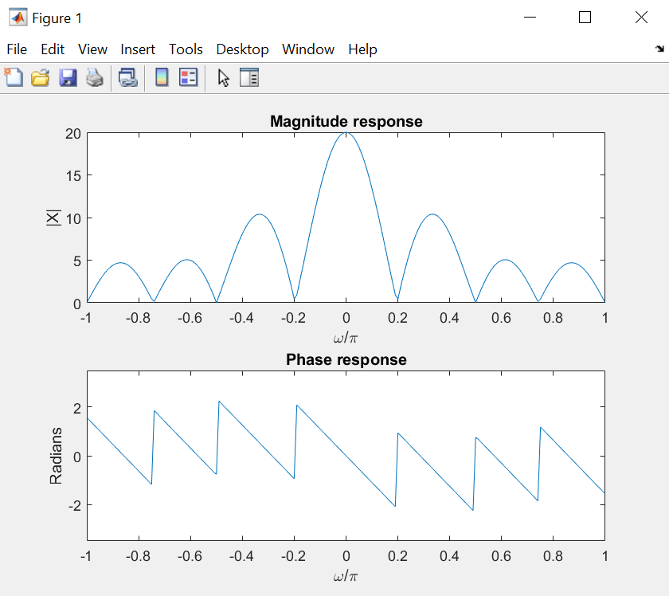

Q2)

x2=cos((pi.\*n2)/9)+0.75\*cos((2\*pi.\*n2)/7)+0.3\*cos((pi.\*n2)/4);

n2=[0:255];

w2= linspace(-pi,pi,2000);

X2=dtft(x2,n2,w2);

magX2=abs(X2);

phaX2=angle(X2);

figure;

subplot(2,1,1);

plot(w2/pi,magX2);

xlabel('\omega/\pi');

ylabel('|X|');

title('Magnitude response');

subplot(2,1,2);

plot(w2/pi,phaX2);

axis([-1,1,-3.5,3.5]);

phatick=[-pi:1.047:pi];

xlabel('\omega/\pi');

ylabel('Radians');

title('Phase response');

